International Diploma In Educational Leadership-Higher Education-
Award Ceremony Tentative List of Awardees
S.No | Name & Address | Photo | Remarks
1 | Dr. Anil Saikia  Principal  Moran college  Moranhat-785670  Email-Anilsaikia1234@rediffmail.com | 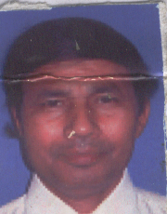
2 | Dr. Bonti Rani Gogoi  Principal,  HPB Girls College,  P.O. Golaghat,  Distt. : Golaghat, Assam, India.  Mobile : 9435526822.  E-mail : bontirani.gogoi@gmail.com | 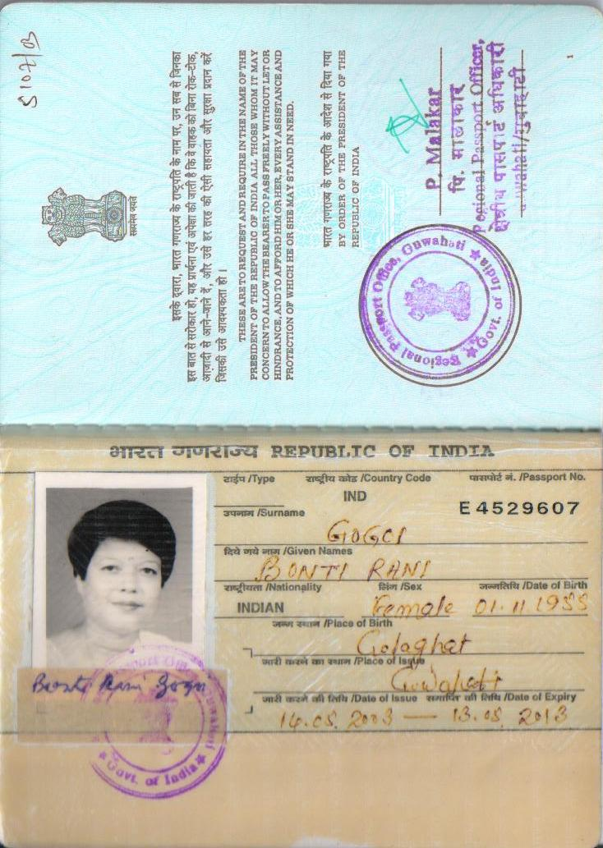
3 | Dr. Charu Saharia Nath  Principal  Tezpur College  P.O. Tezpur,  Distt. : Sonitpur, Assam, India.  Mobile : 9435185339.  E-mail : charusaharianath@gmail.com | 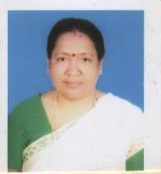
4 | Dr. Malina Devi Rabha  Principal,  Bikali College,  P.O.Dhupdhara  Distt. : Goalpara, Assam, India.  Mobile : 9854901412.  E-mail : malinarabha@gmail.com. | 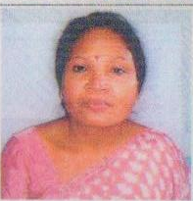
5 | Dr. Mitali Konwar  Principal,  Digboi Mohila Mohabidyalaya,  P.O. Digboi,  Distt. : Tinsukia, Assam, India.  Mobile : 9435031768.  E-mail : mitalikonwar@rediffmail.com | 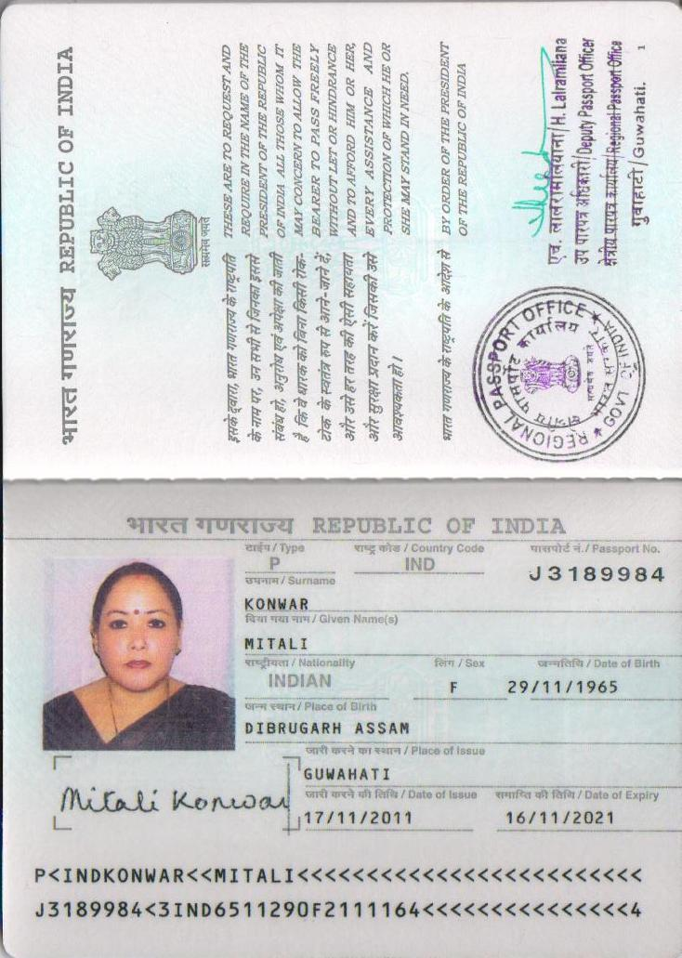
6 | Dr. Ashfia Sultana  Principal,  Amguri College,  P.O. Amguri,  Distt. : Sivasagar, Assam, India.  Mobile : 9435155456.  E-mail :ashfia@rediffmail.com | 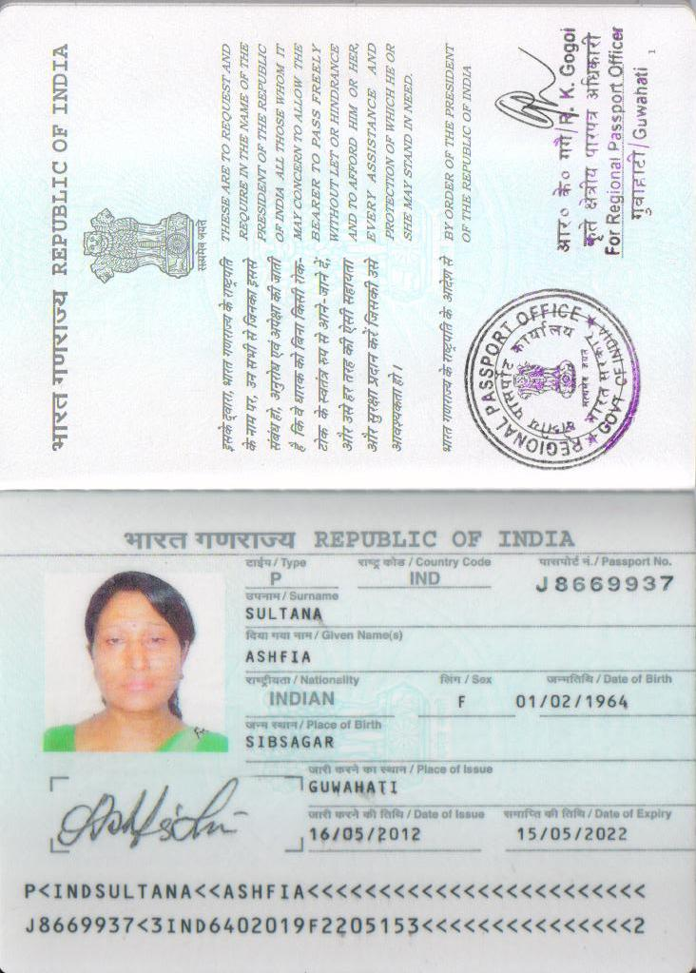
7 | Dr. M Gopal singh  Principal  Head  Department of Geography Bikali College,  P.O.Dhupdharacoming  Distt. : Goalpara, Assam, India.  Mobile : 9854901412.  E-mail : malinaraha@gmail.com. | 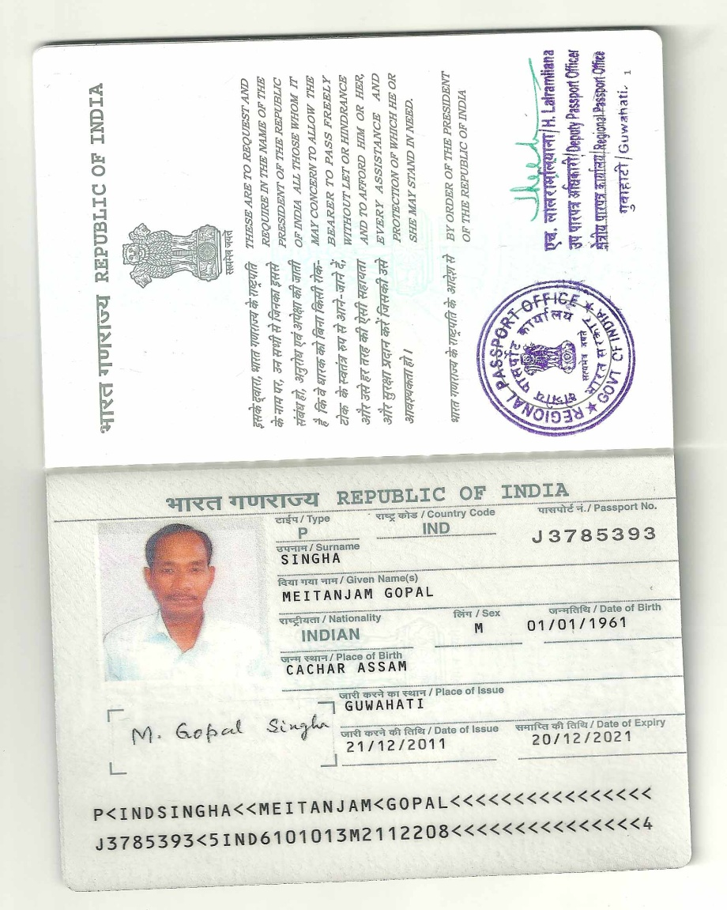
8 | Dr.Jitu Buragohain  Principal  Nampur College  P.O-Parbatpur  Assam-786623  Tel-0374-2500400  Mob-09435332494  Email-jitu.buragohain@gmail.com | 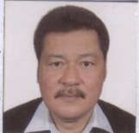
9 | Dr.Balendra Kr. Das  Principal  Paschim Guwahati, Mahavidyalaya  Dharapur  Guwahati-781017  Ph(0)-0361-2840021  Mob-094350-12558  Email-balendra.d@rediffimail.com | 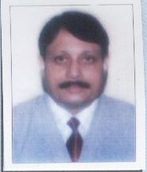
 | DRDR.(MRS.) CHRYSANTHEMUM MASSAR  PRINCIPAL, LADY KEANE COLLEGE,  SHILLONG – 793001  M MEGHALAYA, INDIA  PH PONE. 09863081639  Em email: chrysmassar@gmail.com | 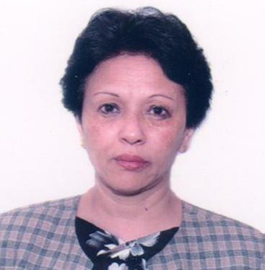
11. | DR. VANESSA KHARMAWPHLANG  PRINCIPAL, COLLEGE OF TEACHER  ED EDUCATION (PGT),  SH SHILLONG – 793003  M MEGHALAYA, INDIA  PH PHONE. 09863021706  Email: vkharmawplang@gmail.com | 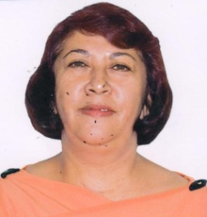
12 | DR.Principal DEBASISH CHOUDHURY  PRI PRINCIPAL, WOMENS COLLEGE,  SHI SHILLONG – 793003  ME MEGHALAYA, INDIA  PH PHONE. 0943630260  Email: cdebasish@gmail.com | 